**Irrigation Methods Water Usage in the United States and Techniques to Ensure Water Efficiency**

**Introduction**

Water usage is an important topic in actuality due to the scarcity of resources. Nowadays, even developed countries struggle to provide all populations with water safety, due to things like climate change and human factors. Water scarcity limits access to safe water for drinking and other regular practices, such as basic hygiene, sewage systems fail and diseases like cholera can get widespread, and if that was not enough water becomes more expensive even for those who have access to it (4). Water scarcity can be relative in the sense that the amount that can be physically accessed varies as supply and demand change, and water being a finite resource is exponentially always in higher demand due to an increasing global population. It is vital to highlight that “Many countries do not have well developed water monitoring systems, which prevents integrated water resource management that can balance the needs of communities and the wider economy, particularly in time of scarcity (5).” To alleviate the situation, it is required to treat water as a scarce resource; Integrated Water Resources Management (IWRM) provides governments with a framework to align water use patterns with the needs and demands of the population, and to take the environment into account. To control water stress IWRM proposes that when a territory withdraws 25% or more of its freshwater reserve, it should be considered as ‘water-stressed.’ As a result, measures like reducing losses from water distribution systems, safe wastewater reuse, desalination, and adequate water relocation can be preventively taken (5).

To contribute to ensuring water access safety to all population, actions can be taken in fields like irrigation, one of the main usages of water globally. More specifically, the problem can be initially addressed in water irrigation methods that are used within the United States. “Irrigation has played a significant role in the development and economy of the United States. It was critical in the settlement of the West and agricultural reinvention after the Dust Bowl” (9). By analyzing three of the main irrigation methods that are utilized in the United States, it will be possible to determine how many acres are irrigated thanks to each method, and through some math formulations, the average or approximate water usage of each one will be calculated. With this information, it will be possible to rank the three methods based on water usage, thus giving a better overview of which methods can have more efficient techniques applied. It is important to recognize that each irrigation method is used based on crop type, soil type, and area climate, but having a summary of how much water is distributed to each one will allow concentrating efforts more effectively. The dataset analyzed in this project comes from the United States Geological Survey (USGS), which focuses on three main irrigation methods that had data gathered in 2015. The first method is Sprinkler Irrigation, which is a system in which water is applied using perforated pipes or nozzles operated under pressure to form spray patterns (8). The second one is Microirrigation, a system that wets only a discrete portion of the soil surface in the vicinity of the plant using applicators (orifices, emitters, porous tubing, or perforated pipe), and operated under low pressure. Applicators can be placed on or below the surface of the ground or suspended from supports (8). At last, Surface Irrigation can be of flood, furrow, or gravity methods; Flood Irrigation, in which the entire soil surface is covered by ponded water; Furrow Irrigation is a partial surface-flooding method of irrigation in which water is applied in furrows or rows of sufficient capacity to contain the designed irrigation stream; finally, Gravity Irrigation works without pumping water, instead flowing in ditches or pipes that get distributed by gravity (8).

The two primary measurements of irrigation water use are water withdrawals and water consumption. Water withdrawals measure the amount of water applied to lands to assist in crop and pasture growth, and water consumption from irrigation refers to the water that is taken in by a plant or evaporated without returning to water sources through runoff or percolation (9). “Irrigation water use is defined as water applied by an irrigation system to assist crop and pasture growth, or to maintain vegetation on recreational lands such as parks and golf courses” (8). For this analysis, only freshwater was considered due to the crescent concern of using drinking water, thus decreasing its availability for human direct consumption. On a more in-depth basis, “Irrigation includes water that is applied for pre-irrigation, frost protection, chemical application, weed control, field preparation, crop cooling, harvesting, dust suppression, leaching of salts from the root zone, and conveyance losses” (8). The initial hypothesis is that water usage will be consistent throughout all categories; irrigation methods with the highest water usage will yield the biggest amount of water used in all contemplated categories. This will give a precise overview of which irrigation methods could benefit the most from implementing improved water efficiency techniques, thus confirming small-scale experiments and datasets through the use of the USGS dataset regarding irrigation in the United States; ranking for usage should be coincident between the small studies and the aforementioned dataset.

**Methods**

Dataset was downloaded as an excel file from the United States Geological Survey (USGS), the file on the webpage can be identified as: usco2015v2.0.xlsx “All Data XLSX”. The original dataset contained 3225 observations, in which 141 variables were in existence (1). The huge number of variables was due to each state having each of its counties categorized with information for all variables. The original dataset was saved independently to avoid modifying base information. A new copy of data was saved using the "save as" option, including in the file names clear distinctions between the original and modified/tidied version. A new glossary sheet was included in the excel data file to define the studied states, avoiding potential confusion about which numbers correspond to each territory. The copied table was highlighted to separate states and water usage categories according to required and usable information.

Highlighting was not included in posterior versions of tables and graphs to avoid formatting problems in excel and CSV files. Using a pivot table, states were more easily categorized with their respective full names; online FIPS (Federal Information Processing Standards) codes, according to The Federal Communications Commission (FCC) are used by the United States government to identify states and counties by their FIPS codes. State-level FIPS codes have two digits, and county-level FIPS codes have five digits of which the first two are the FIPS code of the state to which the county belongs (3). Only overall state data was utilized to prevent an overflow of information and to create more readable and understandable tables and graphs. Pivot tables were used to perform adequate sums of freshwater usage (in millions of gallons per day) and acres irrigated (in thousand acres) throughout the required categories.

Tidying was relatively easy thanks to the DataDictionary attached in one of the original dataset sheets. Three new tables were created to summarize findings in general; arranging all information by all states would have been messy and unreadable. Three charts were formulated from the aforementioned tables by creating summarized tables that entailed all sums in just three categories for each. Through the use of Camel Casing tables were created to avoid problems with spaces. Also, by using the conversion factor 0.8921, thousand acre-feet per year were transformed into approximations of million gallons per day (Mgal/d) (8). At last, charts’ titles and axis titles were modified as appropriate to ensure a correct correlation between data and its corresponding names. It is also worth noting that each chart was created using corresponding tables, and all resulting graphs along with their base data are organized in individual sheets inside of the same workbook to ensure availability. Pivot tables were vital to save time and to ensure that human error was not an obstacle when making accurate sums for all counties of each state.

**Results**

As mentioned before, the original dataset was a 3225 x 141 table, which is not a simple to visualize representation of data. Through some highlighting, the states were initially identified, and using the DataDictionary sheet relevant variables were identified in order to obtain manageable results. For starters, the States Abbreviations sheet obtained through the use of a pivot table was key to identifying all territories studied; thanks to this organization it was possible to recognize some United States territories in the investigation that are not physically part of the United States, such as Puerto Rico. “On July 25, 1898, U.S. forces invaded Puerto Rico and occupied it during the ensuing months of the Spanish-American War. As part of the peace treaty in December 1898, the colony was transferred to the U.S. and a military government took over” (10).

Subsequently, using a pivot table the sum of all states’ counties water usage in general irrigation was calculated (Table 1), measured in millions of gallons per day (Mgal/d). Water usage in general irrigation had a grand total of 73190.12 millions of gallons per day (Mgal/d) in consumptive freshwater usage; sprinkler in general irrigation had a grand total of 34650.05 thousand acres (acre-ft/yr); microirrigation in general irrigation had a grand total of 5485.37 thousand acres (acre-ft/yr); at last surface in general irrigation had a grand total of 23333.39 thousand acres (acre-ft/yr). Next, using another pivot table the sum of all states’ counties water usage in irrigation of crops was calculated (Table 2), measured in millions of gallons per day (Mgal/d). Water usage in irrigation of crops had a grand total of 46094.22 millions of gallons per day (Mgal/d) in consumptive freshwater usage; sprinkler in irrigation of crops had a grand total of 17948.19 thousand acres (acre-ft/yr); microirrigation in irrigation of crops had a grand total of 4727.08 thousand acres (acre-ft/yr); at last surface in irrigation of crops had a grand total of 10652.6 thousand acres (acre-ft/yr). At last, using a third pivot table the sum of all states’ counties water usage in golf irrigation (recreational spaces) was calculated (Table 3), measured in millions of gallons per day (Mgal/d). Water usage in golf irrigation had a grand total of 983.44 millions of gallons per day (Mgal/d) in consumptive freshwater usage; sprinkler in golf irrigation had a grand total of 826.45 thousand acres (acre-ft/yr); microirrigation in golf irrigation had a grand total of 1.65 thousand acres (acre-ft/yr); at last surface in golf irrigation had a grand total of 2.8 thousand acres (acre-ft/yr). It is noteworthy that sprinkler irrigation accounts for almost the entirety of water irrigation methods in the golf irrigation category, which can be a clear indicator that its efficiency is relatively higher than what its usage may represent.

After analyzing the sum pivot tables, three new tables were designed to account in general terms for the three main categories that can be studied. The first table and graph (Graph 1) account for the consumptive usage of freshwater in the three irrigation categories: general irrigation required 73190.12 millions of gallons per day (Mgal/d), irrigation of crops required 46094.22 millions of gallons per day (Mgal/d), and golf irrigation required 983.44 millions of gallons per day (Mgal/d). Next, the second table and graph (Graph 2) describe the number of acres irrigated by each type of irrigation method: sprinkler irrigation supplied water to 53424.69 thousand acres (acre-ft/yr), microirrigation supplied water to 10214.1 thousand acres (acre-ft/yr), and surface irrigation supplied water to 33988.79 thousand acres (acre-ft/yr). The third table and graph (Graph 3) account for the estimated water usage of each irrigation method using the 0.8921 conversion factor to change a thousand acre-feet per year (acre-ft/yr) into approximations of million gallons per day (Mgal/d) (1); sprinkler irrigation utilized 47660.17 millions of gallons per day (Mgal/d), microirrigation utilized 9111.99861 millions of gallons per day (Mgal/d), and surface irrigation utilized 30321.39956 millions of gallons per day (Mgal/d). It is worth mentioning that water usage and acres irrigated data can be reliably compared to another information source that has similar data, but for 2013 (Graph 4) (9).

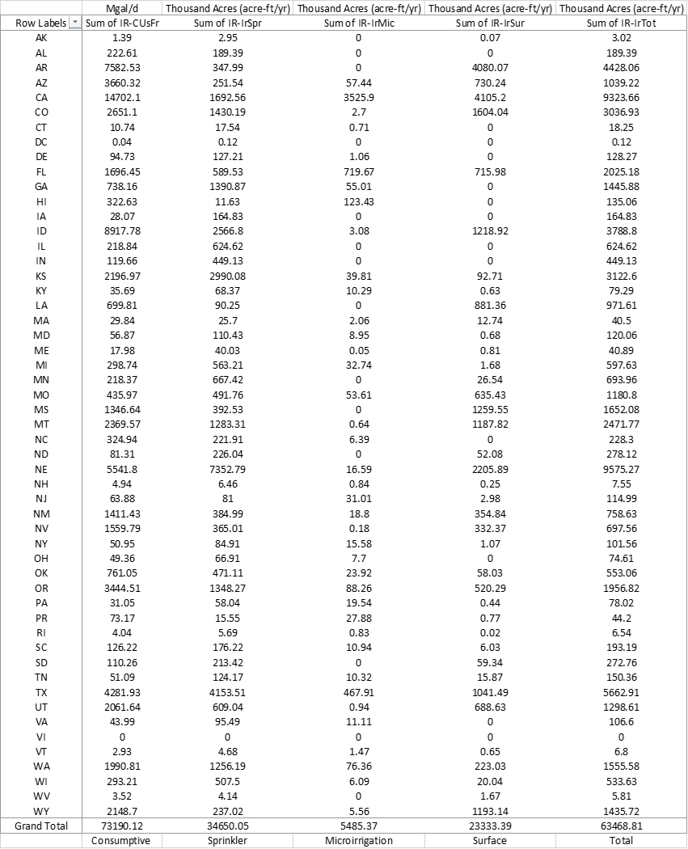

Table

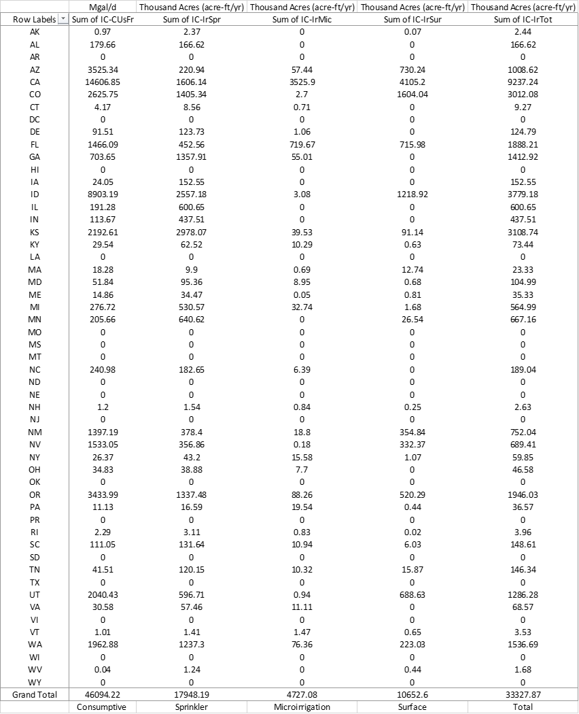

Table

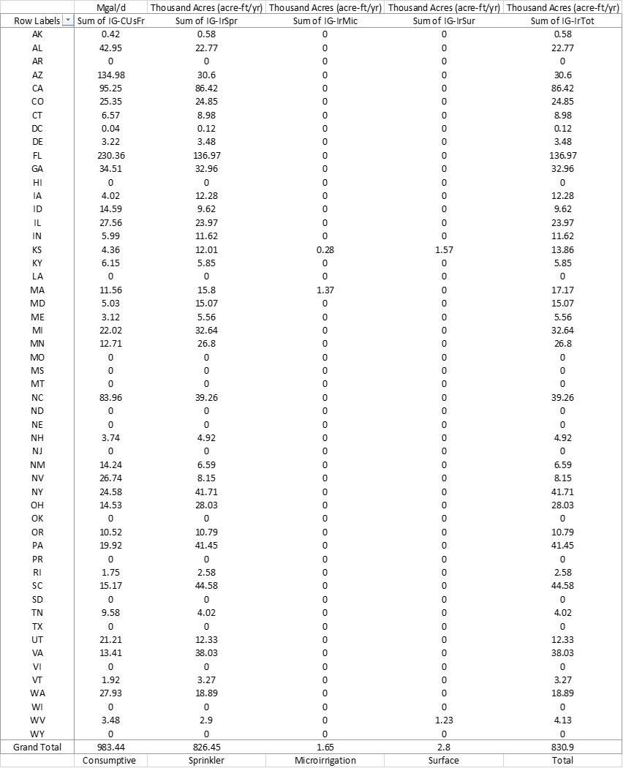

Table

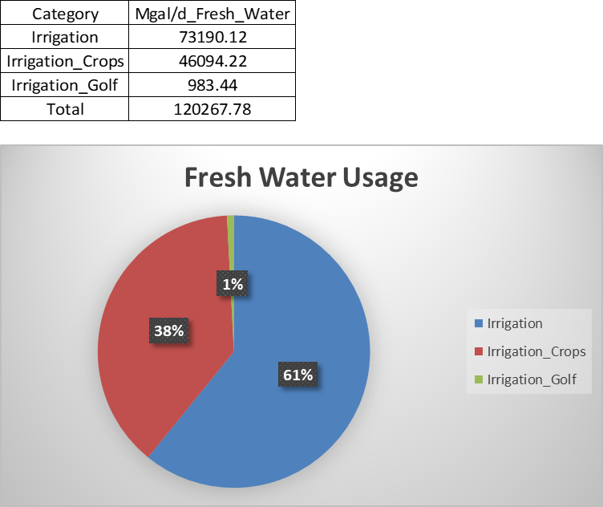

Graph 1

Total Consumptive Use of Freshwater per category using Tables 1, 2, and 3

Irrigation: Watering of plants in other categories.

Irrigation_Crops: Watering of plants used for food and nutrition.

Irrigation_Golf: Watering of plants in recreational spaces such as parks and golf courses.

Graph 2

Sums of Tables 1, 2, and 3 per category

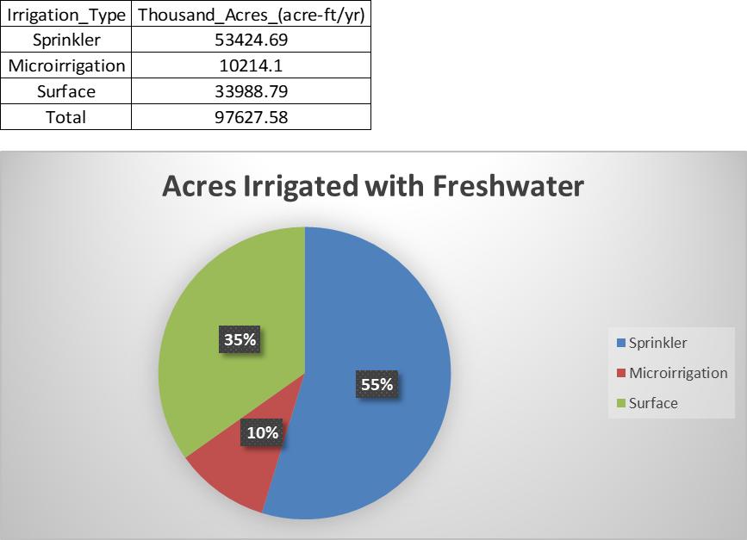

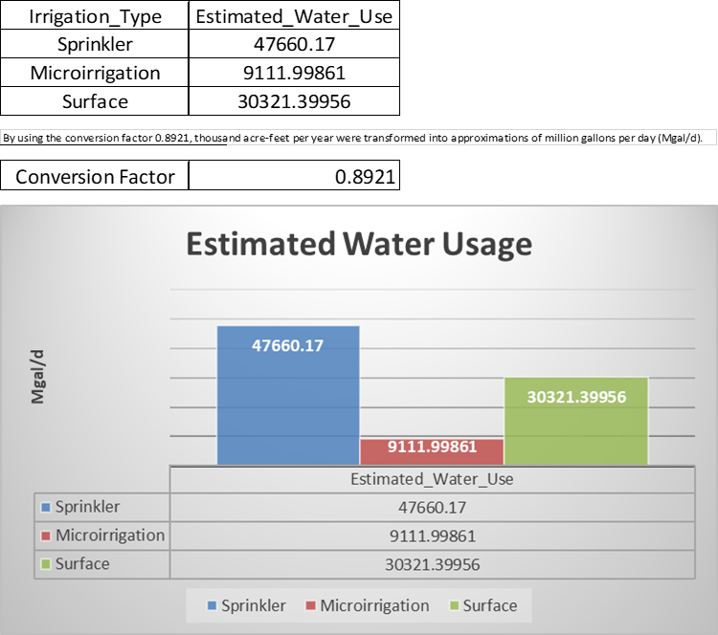

Graph 3

Conversion of Graph 2 using Conversion Factor: 0.8921

Use in the United States

1st = Sprinkler

2nd = Surface

3rd = Microirrigation

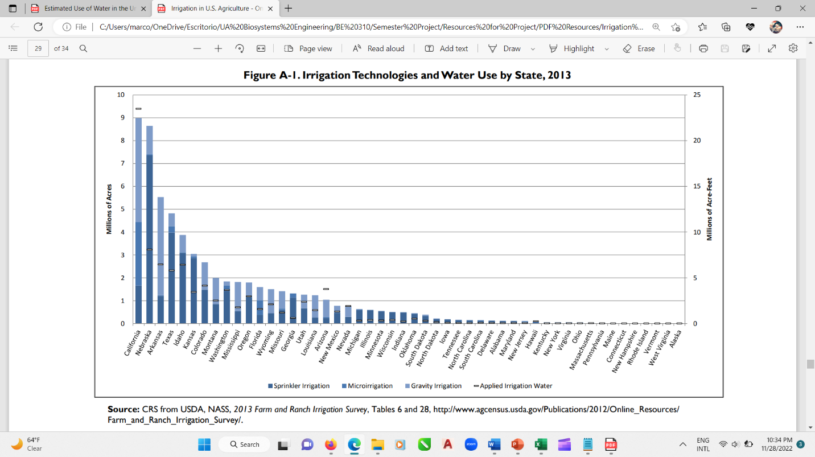

Graph 4

**Discussion and Conclusion**

It has been studied how long irrigation sets can waste water. When in short supply, like in drought seasons, practices need to be reworked to obtain maximum benefit from the limited water available. Even when water is plentiful, saving it is a great practice. Using water excessively can waste soil and fertilizer in water runoff, resulting in deep percolation and leaching of nitrates, nitrites, and other farm chemicals; this contributes to increasing the total daily load of chemicals carried by aquifers. (2) Irrigation efficiency practices are not specific just to one type of irrigation method, which means all of them can be benefited from said practices. This includes, but is not limited to: irrigation scheduling, deficit irrigation, and conservation tillage. These strategies can entail additional costs, but in the long run, they end up saving more money and water, leading to higher market value of crops in general. Scheduled Irrigation Based on Evapotranspiration (ET) works based on the optimal time and intervals to irrigate. This depends on each type of crop, which means efforts to evaluate each one are required. ET charts from the Bureau of Reclamation AgriMet system can be used to determine fairly accurate estimates of crop water use, helping determine when and how to irrigate. Scheduled Irrigation Based on Soil Water Content or Soil Water Tension works based on the use of soil-moisture monitoring equipment to measure how much moisture is in the soil. These instruments, when used with ET charts, provide a fairly accurate estimate of irrigation needs (2). Deficit Irrigation applies less water than the crop needs for full development. “Some crops lose little yield and quality with modest irrigation deficits, saving water” (2). Some plants handle drought stress much better than others, with yield and quality positively related to some water deficit during part of the growing season. Deficit irrigation is less successful with crops whose quality is depressed by water stress, like potatoes and vegetable crops, such as onions. Plan Acreage Under Irrigation works under the premise that when water supplies are short, it is better to plant crops that require less water; when multiple crops are struggling with remaining water, prioritize saved water for high-value crops. At last, Sedimentation Basins with Pump-Back Systems can be used to collect runoff and reuse it, depending on the amount of energy that could be required to reuse water. (2)

“While a traditional sprinkler system uses as much as 400 gallons per hour (gph), micro-irrigation emitters have a maximum flow rate of 30 gph” (6). On the other hand, it is worth noting that surface irrigation systems can use 800 gph on average, doubling the average use of sprinklers, and using almost twenty-seven times the amount required by microirrigation systems (7). From the resulting graphs of this study, it can be confirmed that data align for the most part with these water usage estimations. Sprinkler Irrigation was calculated to irrigate 53424.69 thousand acres (acre-ft/yr) using 47660.17 millions of gallons per day (Mgal/d); Microirrigation was calculated to irrigate 10214.1 thousand acres (acre-ft/yr) using 9111.99861 millions of gallons per day (Mgal/d); at last, Surface Irrigation was calculated to irrigate 33988.79 thousand acres (acre-ft/yr) using 30321.39956 millions of gallons per day (Mgal/d). Microirrigation proved to be the most efficient irrigation method, and Sprinkler and Surface Irrigation seem to have odd results; that is until the number of acres irrigated is considered along with the daily required gallons. Overall, the three methods align with previous estimations and smaller studies, and following said pattern in which Microirrigation is the most efficient, Sprinkler Irrigation is the second most efficient, and Surface Irrigation is the least efficient, future studies about how to implement the previously mentioned irrigation efficiency practices can be done focusing attention prioritizing these three irrigation methods according to their water usage. Even when other conditions like climate, crop type, and soil type for all irrigation methods cannot be categorized together in the same study, having a good general scope of water usage will permit to focus attention on entailing methods that require the highest amount of water to obtain a greater yield and savings.

**Data**

<https://github.com/Marcos4525/BE-310-Semester-Project-Resources.git>

**References**

1. S. for a C. W. USGS, Estimated Use of Water in the United States County-Level Data for 2015 - ScienceBase-Catalog. *www.sciencebase.gov* (2017) Available at <https://www.sciencebase.gov/catalog/item/get/5af3311be4b0da30c1b245d8> (November 5, 2022).

2. C. C. Shock, B. M. Shock, T. Welch, “Strategies for Efficient Irrigation Water Use” Available at <https://catalog.extension.oregonstate.edu/em8783> (Oregon State University, 2013).

3. U.S. Bureau of Labor Statistics, Appendix D ‐ USPS State Abbreviations and FIPS Codes: U.S. Bureau of Labor Statistics. *www.bls.gov* (2005) Available at <https://www.bls.gov/respondents/mwr/electronic-data-interchange/appendix-d-usps-state-abbreviations-and-fips-codes.htm> (November 20, 2022).

4. UNICEF, Water Scarcity. *UNICEF* Available at <https://www.unicef.org/wash/water-scarcity> (2020).

5. United Nations, Water Scarcity. *UN-Water* Available at <https://www.unwater.org/water-facts/water-scarcity> (2021).

6. A. Yasalonis, Micro-Irrigation: A Water Saving Alternative. *UF/IFAS Extension Polk County* (2019) Available at <https://blogs.ifas.ufl.edu/polkco/2019/07/10/micro-irrigation-a-water-saving-alternative/> (November 26, 2022).

7. ScienceDirect, Furrow Irrigation - Agricultural Water Management, 2002. *www.sciencedirect.com* (2005) Available at <https://www.sciencedirect.com/topics/earth-and-planetary-sciences/furrow-irrigation> (November 24, 2022).

8. C. A. Dieter, *et al.*, Estimated use of water in the United States in 2015. *pubs.er.usgs.gov*, 76 (2018) Available at <https://pubs.er.usgs.gov/publication/cir1441>.

9. M. Stubbs, “Irrigation in U.S. Agriculture: On-Farm Technologies and Best Management Practices Megan Stubbs Specialist in Agricultural Conservation and Natural Resources Policy” (2016) Available at <https://www.everycrsreport.com/reports/R44158.html> (November 10, 2022).

10. E. BLAKEMORE, Why Puerto Rico has debated U.S. statehood since its colonization. *History* (2020) Available at <https://www.nationalgeographic.com/history/article/puerto-rico-debated-statehood-since-colonization> (November 28, 2022).